37. Scenario: You are a data scientist working for an educational institution, and you want to

explore the correlation between students' study time and their exam scores. You have collected data

from a group of students, noting their study time in hours and their corresponding scores in an

exam.

Question: Identify any potential correlation between study time and exam scores and explore

various plotting functions to visualize this relationship effectively.

Code:

import pandas as pd

import matplotlib.pyplot as plt

import seaborn as sns

from scipy.stats import pearsonr

# Load the student study and score data

file_path =r"C:\Users\jampa\Downloads\student_study_scores.csv"

df = pd.read_csv(file_path)

def analyze_study_score_correlation(df):

# Calculate correlation coefficient

correlation, p_value = pearsonr(df['Study_Time_Hours'], df['Exam_Score'])

print(f"Correlation Coefficient: {correlation:.2f}")

print(f"P-Value: {p_value:.4f}")

# Scatter plot with regression line

plt.figure(figsize=(8,4))

sns.regplot(x='Study_Time_Hours', y='Exam_Score', data=df, ci=None, scatter_kws={'color': 'blue'}, line_kws={'color': 'red'})

plt.title('Study Time vs Exam Score')

plt.xlabel('Study Time (Hours)')

plt.ylabel('Exam Score')

plt.grid(True, linestyle='--', alpha=0.6)

plt.show()

# Distribution plot

plt.figure(figsize=(8,4))

sns.histplot(df['Exam_Score'], kde=True, color='purple')

plt.title('Distribution of Exam Scores')

plt.xlabel('Exam Score')

plt.ylabel('Frequency')

plt.grid(True, linestyle='--', alpha=0.6)

plt.show()

# Run the analysis

analyze_study_score_correlation(df)

output:

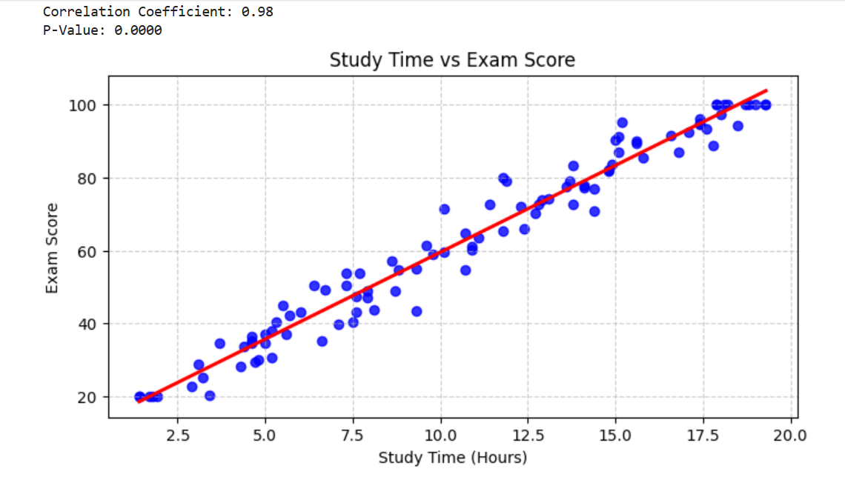

Dataset:

|  |  |  |
| --- | --- | --- |
| Student_ID | Study_Time_Hours | Exam_Score |
| S001 | 8.6 | 57.2 |
| S002 | 19.3 | 100 |
| S003 | 5.2 | 30.7 |
| S004 | 16.6 | 91.3 |
| S005 | 3.2 | 25.3 |
| S006 | 12.9 | 73.9 |
| S007 | 15.6 | 90 |
| S008 | 17.1 | 92.4 |
| S009 | 18.8 | 100 |
| S010 | 6 | 43 |
| S011 | 14.4 | 70.8 |
| S012 | 1.9 | 20 |
| S013 | 15.1 | 86.9 |
| S014 | 15.8 | 85.5 |
| S015 | 7.1 | 39.8 |
| S016 | 17.4 | 94.8 |
| S017 | 7.5 | 40.5 |
| S018 | 5.7 | 42.1 |
| S019 | 3.7 | 34.5 |
| S020 | 6.6 | 35.2 |
| S021 | 14.8 | 81.7 |
| S022 | 4.4 | 33.6 |
| S023 | 13.8 | 83.2 |
| S024 | 5.5 | 45.1 |
| S025 | 14.1 | 77.1 |
| S026 | 9.3 | 43.5 |
| S027 | 18 | 97.3 |
| S028 | 10.1 | 71.5 |
| S029 | 10.1 | 59.6 |
| S030 | 14.4 | 76.8 |
| S031 | 11.8 | 79.8 |
| S032 | 4.8 | 30.2 |
| S033 | 18.7 | 100 |
| S034 | 10.7 | 54.6 |
| S035 | 6.4 | 50.5 |
| S036 | 9.3 | 54.9 |
| S037 | 18.2 | 100 |
| S038 | 14.9 | 83.5 |
| S039 | 10.9 | 61.1 |
| S040 | 15.6 | 89.4 |
| S041 | 11.4 | 72.5 |
| S042 | 12.4 | 66 |
| S043 | 4.7 | 29.6 |
| S044 | 15.1 | 91.1 |
| S045 | 4.6 | 34.7 |
| S046 | 5.3 | 40.5 |
| S047 | 1.8 | 20 |
| S048 | 13.7 | 79 |
| S049 | 8.8 | 54.6 |
| S050 | 12.3 | 72 |
| S051 | 7.3 | 53.9 |
| S052 | 17.9 | 100 |
| S053 | 17.9 | 100 |
| S054 | 5 | 37.1 |
| S055 | 12.7 | 70.2 |
| S056 | 7.3 | 50.5 |
| S057 | 4.6 | 36.4 |
| S058 | 11.1 | 63.5 |
| S059 | 11.9 | 78.9 |
| S060 | 10.7 | 64.6 |
| S061 | 7.7 | 53.7 |
| S062 | 5.2 | 37.9 |
| S063 | 13.8 | 72.5 |
| S064 | 7.9 | 48.9 |
| S065 | 19.3 | 100 |
| S066 | 1.4 | 20 |
| S067 | 8.1 | 43.7 |
| S068 | 11.8 | 65.4 |
| S069 | 9.6 | 61.4 |
| S070 | 13.6 | 77.6 |
| S071 | 4.6 | 35.2 |
| S072 | 17.4 | 96.1 |
| S073 | 7.9 | 47 |
| S074 | 3.4 | 20.5 |
| S075 | 13.1 | 74.2 |
| S076 | 1.7 | 20 |
| S077 | 18.5 | 94.3 |
| S078 | 17.8 | 88.6 |
| S079 | 14.1 | 77.8 |
| S080 | 5 | 34.8 |
| S081 | 19 | 100 |
| S082 | 17.4 | 94.4 |
| S083 | 18.1 | 100 |
| S084 | 7.6 | 43.2 |
| S085 | 1.4 | 20 |
| S086 | 16.8 | 86.9 |
| S087 | 3.1 | 28.9 |
| S088 | 12.8 | 72.5 |
| S089 | 5.6 | 37 |
| S090 | 17.6 | 93.3 |
| S091 | 15.2 | 95.1 |
| S092 | 10.9 | 60.1 |
| S093 | 14.8 | 82 |
| S094 | 7.6 | 47.4 |
| S095 | 6.7 | 49.3 |
| S096 | 2.9 | 22.8 |
| S097 | 8.7 | 49 |
| S098 | 4.3 | 28.4 |
| S099 | 15 | 90.2 |
| S100 | 9.8 | 59 |